For Immediate Release

Delta to Highlight its Strengthened Capabilities in Automation & Energy Management Solutions for Smart Factories and Green Buildings at Hannover Messe 2016

Hannover, Germany, March 31st, 2016 – Delta, a leader in power and thermal management solutions, will exhibit, at Hannover Messe 2016, an enhanced spectrum of automation and energy management solutions with leading energy efficiency for smart factories, green buildings, renewable energy systems, EV charging networks and more. Delta’s smart integrated factory solution will feature “customer-centric” logistics management, real-time monitoring and management via the VidaGridTM internet cloud service. Our building automation solutions, Building Management and Control System and Delta Energy Online, recently installed at Delta’s Americas HQs (poised to become the 1st net-zero green building in Fremont, Ca., USA) will also be major highlights of our showcase along with the new 25kW Wallbox DC Quick EV Charger.
Our innovative, comprehensive and energy-efficient portfolio of solutions at Hannover Messe 2016, will include:
- Industrial Automation Solutions: Delta’s Integrated Factory Control Platform integrates the mid-range PLC AH500 Series as host controllers, the SCADA System DIAView and the industrial energy management system DIAEnergie for real-time manufacturing process monitoring. All data is managed by the Industrial PC IPC Series and preserved by the VidaGridTM internet cloud service for customers’ real-time management. This system architecture fosters higher productivity and flexibility in a wide range of manufacturing processes with its “customer-centric” logistics management approach.
Other automation solutions include the Multiple Water Pumps Control Solution and CNC solutions. The Multiple Water Pumps Control Solution is for applications in HVAC systems, water treatment and related fields. Delta will also demonstrate automation solutions for food packaging, energy saving for elevators and power quality.

Within the full range of AC motor drives, AC servo drives, PLCs, industrial PCs, machine vision solutions, HMIs, industrial Ethernet switches and smart sensors, the AS Series PLC, featuring a 32 bit SoC CPU, is able to control up to 8 axes via CANopen motion network or up to 6 axes via pulse control (200kHz). Our new compact drives, MH300 and MS300 Series, with up to 40% size reduction and built-in PLC, support open/closed loop control for both IM and PM motors.
- Building Automation Solutions: The Building Management and Control System (BMCS) is an IP-based integrated and extensive platform for centralized management and distributed control of several systems with different protocols within building operations to improve efficiency and to reduce costs. Another solution for buildings is the Delta Energy Online, a web-based tool for energy monitoring and visual analytics as well as advanced energy consumption diagnostics that support strategic plans for energy savings in buildings. These solutions have recently been implemented at Delta’s headquarters for the Americas region, and currently support the building to become the 1st net-zero energy green building in Fremont, Ca., USA.

- Battery Energy Storage Solutions: Delta’s latest lithium-ion battery modules are valid energy storage alternatives for a wide range of applications. The DBSHV50S high-voltage module, each with 2.59 kWh nominal energy, offers flexible configuration of systems from 48V to 900V and up to MWh-level capacity. These modules support functions such as peak shaving, time shifting and utility ancillary services in commercial and renewable energy storage applications. The DBS48V50P battery module is ideal for energy storage in 48V applications such as residential, telecom systems, data centres and even electric forklifts.
- Renewable Energy Solutions: Our showcase at Hannover Messe 2016 will feature wind power converter technology with leading 98% energy efficiency for electrical excited and permanent excited generators as well as converters for double fed induction generators for wind turbines up of to 6MW in 690V technology and of up to 10MW in medium voltage technology. For the solar PV industry, Delta offers a vast portfolio of single-phase and three-phase PV inverters from 3kVA to 55kVA capacity and a remarkable track record in PV installations across EMEA. Our PV inverters boast industry-leading energy conversion efficiency of up to 98.7%.
- EV Charging Solutions: The brand-new 25kW Wallbox DC Quick EV Charger offers a lightweight structure and pluggable modular power system architecture for a meaningful reduction in installation and maintenance costs. Its simultaneous dual output boosts convenience as two EVs can be recharged at the same time without sacrificing charging speed. The system is ideal for commercial segments such as EV parking, fleet charging and even residential as it supports RFID and mobile app user access.
Delta’s new 25kW Wallbox DC Quick EV Charger can recharge the battery of a Nissan Leaf from 0% to 80% within 40mins.

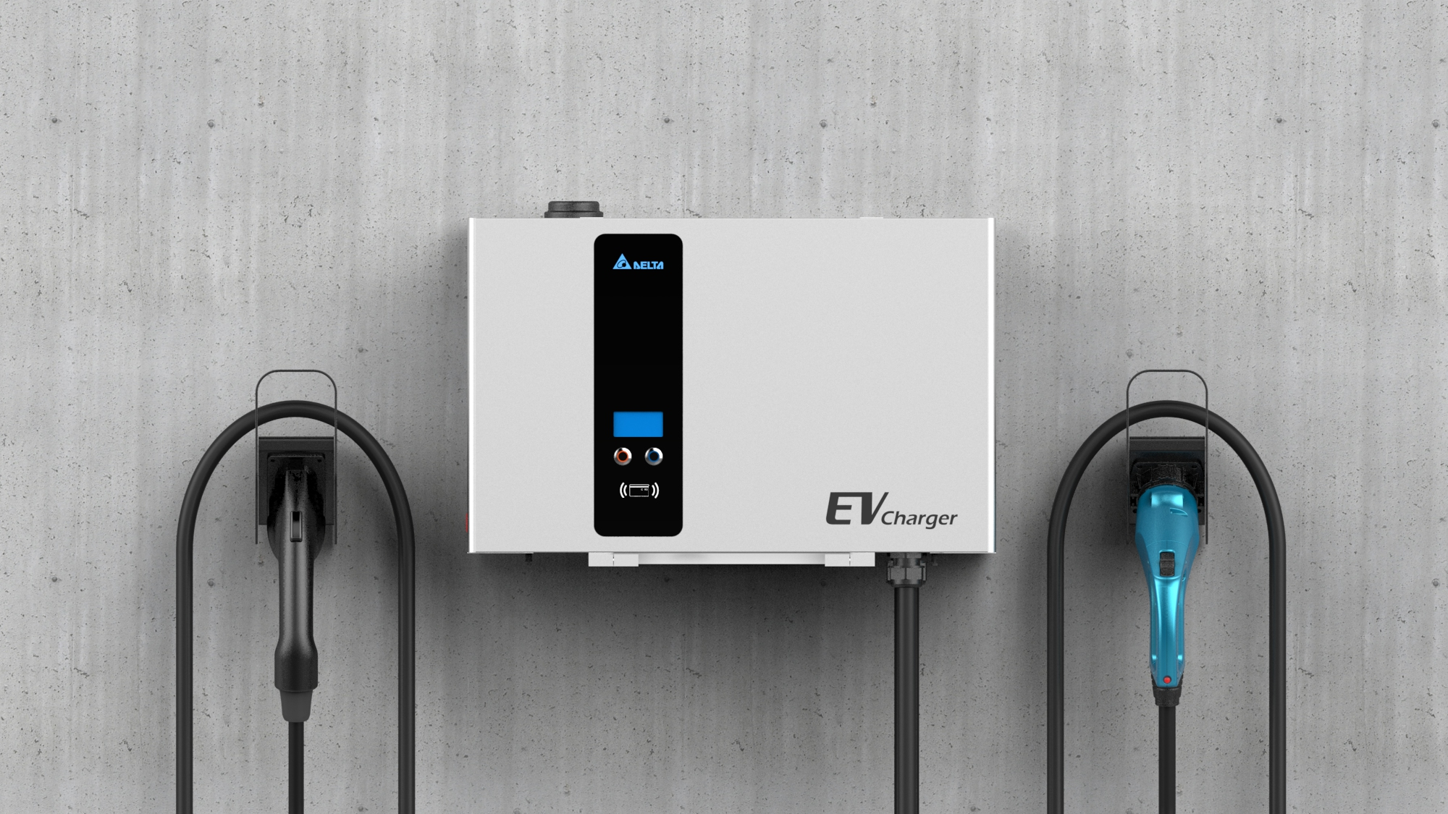

- Datacentre Infrastructure Solutions & UPS: This year, Delta will exhibit energy-efficient UPS models for customers that require reliable power protection and energy savings in their IT operations. The 500kVA Ultron DPS series UPS, featuring IGBT topology to achieve industry-leading 96% AC-AC efficiency, low iTHD < 3% and high-input power factor > 0.99, is designed for green data centres mission as well as mission critical applications in the banking, healthcare, telecom and more. The Ultron HPH series with 20kVA to 120 kVA power rating, recently selected by a world-class German luxury auto manufacturer, also boasts IGBT topology, leading AC-AC efficiency of 96% and full power factor (kVA = kW).
- Telecom Network Energy Solutions: The Golden Eagle small cell power system for 4G networks – recent winner of the 2016 iF Design Award –, outdoor power systems integrating hybrid energy sources, solutions for remote power network monitoring and control and rectifiers with industry-leading energy efficiency of up to 97.5% are all a testament of Delta’s commitment to help customers realize substantial opex and energy savings and a lower carbon footprint from their telecom operations.
Delta shall be present at Hannover Messe 2016, Hall 11, stand A49 between April 25th to 29th, 2016, Hannover, Germany.
.# # #
About Delta
Delta, founded in 1971, is a global leader in power and thermal management solutions and a major player in several product segments such as industrial automation, displays, and networking. Its mission statement, “To provide innovative, clean and energy-efficient solutions for a better tomorrow,” focuses on addressing key environmental issues such as global climate change. As an energy-saving solutions provider with core competencies in power electronics and innovative research and development, Delta's business domains include Power Electronics, Energy Management, and Smart Green Life. Delta has 153 sales offices, 60 R&D centers and 38 manufacturing facilities worldwide now.
Throughout its history, Delta has received many global awards and recognition for its business achievements, innovative technologies and dedication to corporate social responsibilities. Since 2011, Delta has been selected as a member of Dow Jones Sustainability™ World Index (DJSI World) for 5 consecutive years. In 2014, Delta was ranked by CDP (formerly the Carbon Disclosure Project) on the highest A-level of the Climate Performance Leadership Index (CPLI), and is the only one from nearly 2,000 listed companies in Greater China that makes to CPLI list.
For detailed information about Delta, please visit: www.deltaww.com and www.delta-emea.com
Media Contact:
Andreas Schmidt  Head of Marketing  Delta EMEA  Tel: +49 07641455252  E-mail: andreas.schmidt@deltaww.com | Colleen Ho  Communications Manager  Delta EMEA  Tel: +31 206550977  E-mail: colleen.ho@deltaww.com

